GUERNSEY SOCIETY
OF DOWSERS
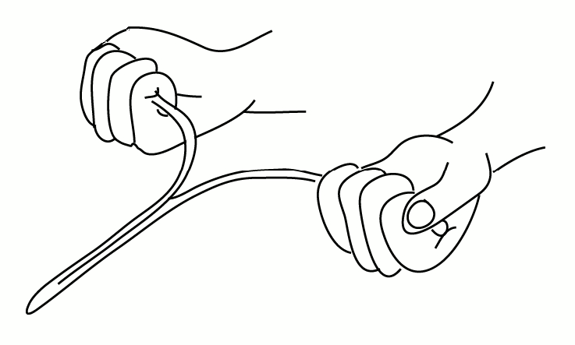

PROGRAMME JANUARY – JULY 2019

ALL INDOOR EVENING MEETINGS START at 7.00 pm – CHECK SHEET FOR VENUES.
SATURDAY DROP-IN SESSIONS (entrance free) ARE AT LES COTILS - ANY TIME BETWEEN 12.30-2.00.
EVENING MEETINGS ARE FREE TO FULLY SUBSCRIBED MEMBERS AND, UNLESS OTHERWISE STATED, DONATIONS ARE INVITED FROM NON-MEMBERS. MEETINGS MARKED WITH * DENOTES EXTRA PAYMENT FOR WORKSHOP COSTS (MEMBERS ONLY).

Thursday 17th Jan Guest - Jason Monaghan – Follow up on “Alderney Excavations” – at Castel Douzaine
Saturday 26th Jan Drop In – Les Cotils (Room 1) 12.30 – 2.00 p.m.

Friday 15th Feb Health Special Interest Group – Ariana Heartsong – Soundbath – at Castel Douzaine
Thursday 21st Feb How to measure subtle energies using The Bovis Biometer –
Talk & Practical led by Tony Talmage – at Castel Douzaine
Saturday 23rd Feb Drop In– Les Cotils (Room 1) 12.30 – 2.00 p.m.

Thursday 7th Mar A.G.M. - followed by Speed Dowsing at Castel Douzaine
AGM 6.30 start. Dowsing 7.00 p.m. start
Friday 22nd Mar Guest: Adrian Incledon-Webber - Talk on Spiritual Earth at the Reading Room at Les Cotils
Saturday 23rd Mar Workshop - with Adrian Incledon Webber * £15 per person (Members Only)
Saturday 30th Mar Drop In– Les Cotils (Room 1) 12.30 – 2.00 p.m.

Thursday 11th Apr Health Special Interest Group - TBC
Thursday 18th Apr Site Visit – Le Galloudec Sacred Heart Shrine at Fort Hommet (with the option of a bar supper afterwards) – Meet at 6.45 p.m.
Saturday 27th Apr Drop In – Les Cotils (Room 1) 12.30 – 2.00 p.m.

Thursday 2nd May Site Visit – Venue TBC
Thursday 23rd May Health Special Interest Group – Life Balance/Body Mapping.
Talk & Practical led by Sue Taylor – at Castel Douzaine
Saturday 25th May Drop In – Les Cotils (Room 1) 12.30 – 2.00 p.m.

Thursday 6th June Health Special Interest Group – Lucia from Healing Hands –more details to follow.
Friday 21st June Site Visit - Summer Solstice Celebration
Saturday 29th June Drop In – Les Cotils (Room 1) 12.30 – 2.00 p.m.

Sneaky Peak - Coming up in September:
Friday 13th Sept Guest: Lucy Pringle, Speaker & International Authority on Crop Circles

To have your name added to our emailing list, please contact either: Nigel Clarke, Chairman on 07781 103486 or email Nigel Clarke clarkenigel257@yahoo.co.uk or Marilyn Page, Secretary on email marilynguernseydowsing@gmail.com. Check any changes to this programme and keep up to date with all Guernsey dowsing news and info by accessing our website: www.guernseydowsers.co.uk or via Facebook https://www.facebook.com/guernseydowsers

