www.guernseydowsers.co.uk 2019
GUERNSEY SOCIETY
OF DOWSERS
Affiliated with the British Society of Dowsers
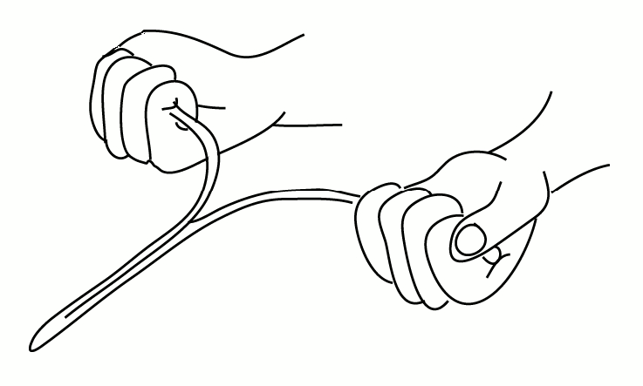

To ensure we have your correct contact details, please complete this form and return it to Marilyn Page, Secretary, Guernsey Society of Dowsers, c/o Edelweiss, Les Landes, Vale, Guernsey, GY3 5JJ

We will use this information to ensure that you are kept fully informed about Society events.

Personal Details

Name……………………………………………………………………………………………………….

Contact Phone Number or Mobile …………………..………………………………………………….

E-mail Address…………………………………………………………………………………………….

Or if you do not have an email address or prefer to receive information via post:

Address…………………………………………………………………………………………………….

…………………………………………………………….…… Post Code ……………………………..

Please tick one of the boxes below:
I wish to be a member of the GSD and I enclose cash or a cheque for £25.00 made payable to “Guernsey Society of Dowsers”. This will give me free admission to local events but I understand additional charges will be made for some workshops*.
I do not wish to be a member of the GSD but I do wish to be included on the GSD mailing list to be kept informed of events and I acknowledge that I shall have to pay a fee at the door of most events. **

* Members also have voting rights at the AGM.
** Non members are invited to make a donation at each event to help cover costs.

Signature…………………………………………………………………………………………………

